Highlights of project meeting “Strengthening strategic delta planning processes in Bangladesh, the Netherlands, Vietnam and beyond”
Date: June 08, 2016
Venue: UNESCO-IHE Institute for Water Education , Delft
Report by Chris Seijger and Shahnoor Hasan

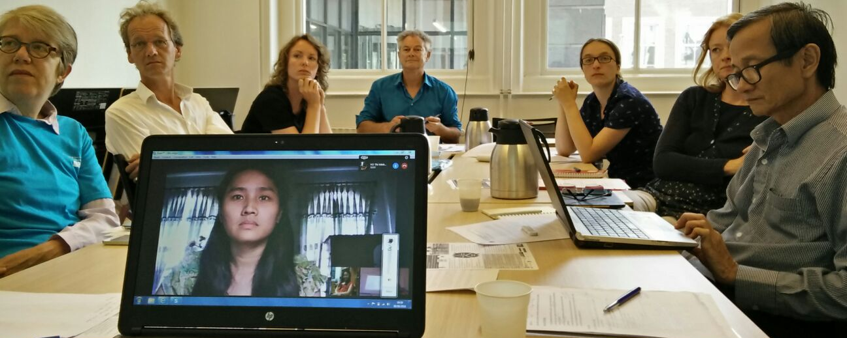
INTRODUCTION
-Wim Douven opens the meeting. Main objectives of today are to inform each other about progress of researchers and discuss activities of project consortium members. The researchers are well on track, PhD proposals nearly ready to be submitted, Myrthe is replaced by Dorien Korbee (postdoc TU Delft). We received results of review Hourglass paper, major, but doable revisions are needed.
-Ideas for a training workshop on strategic delta planning and planning tools have been discussed with PBL, BS and Deltares. Everybody is positive about this idea, we will discuss today a first schedule for the workshop and explore what is needed to organize the workshop.

RESEARCH PITCHES
The presentations are compiled into one presentation, accessible through https://www.dropbox.com/s/0j07gybzygc681o/master%20powerpoint%20consortium%20meeting.pdf?dl=0
-Chris Seijger on the theoretical lenses of the Hourglass and MOTA, Hourglass case study Mekong Delta Plan.
-Shahnoor Hasan on what participatory planning tools do in different contexts: context of use, expectation and design.
-Vo Thi Minh Hoang on the role of innovative solutions in delta planning and the Vietnamese planning system.
-Ho Long Phi on MOTA, findings MOTA survey An Giang, transforming MOTA and suggestions for further development

Remarks that were provided are put at the end of this report.
ACTIVITIES DUTCH CONSORTIUM PARTNERS
The presentations are compiled into one presentation, accessible through (##).
-Maaike van Aalst sketches four activities: link with SDP researchers, reflection on participatory scenario development (workshops + paper), framework to evaluate planning tools, reflect on MOTA.
-Maike Warmerdam sketches two main activities: reflection on design charrettes, training workshop tools strategic delta planning.
-Leo Pols mentions 4 activities: Denvis workshops, learn about dynamics between participatory planning tools in Asian context, reflect on value of planning tools in comparison with actor coalitions and innovative solutions, improve participatory planning tools to offer practical support for more successful delta planning processes.
-The MSc student that will work on an evaluation framework should discuss key dimensions with these consortium partners. During the discussion the following dimensions were mentioned: bring participants out of their normal frame, the role of the facilitator, having a vision.
-Another output of applying the evaluation framework is that it may become clear what skills are needed to do for instance research by design. We could also think about developing a course, training people to facilitate research by design.

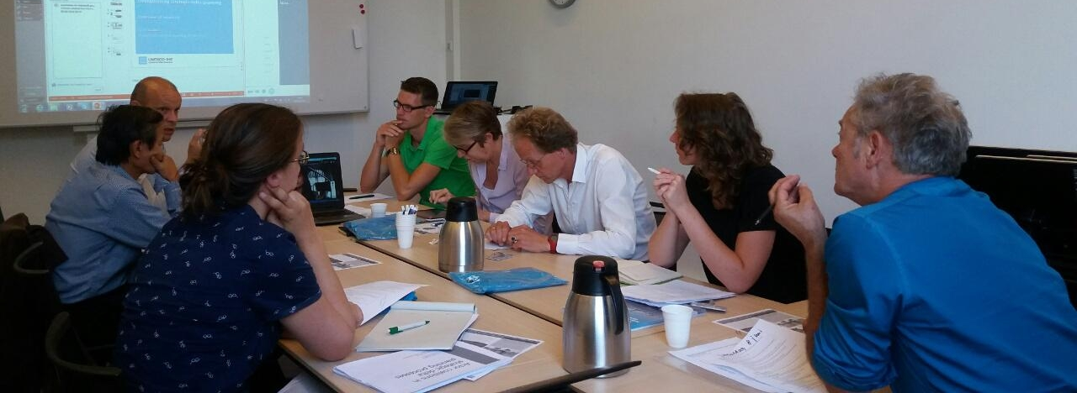
TRAINING WORKSHOP
Wim briefly explains the concept program of the workshop. The draft is a good starter but has to be discussed soon in more detail. The discussion covered:
-Feasibility, since September is coming soon, especially with summer holidays preparations should start quickly.
-What exactly is the purpose of the workshop? Is it focusing on showcasing, or a comparison of user experiences? Will it be designed as experimental set up (with parallel sessions?)?
-Best is to take a case outside Bangladesh, to avoid strings with BDP and to avoid that people with in-depth Bangladesh knowledge dominate discussions over participants from other deltas.
-A logical sequence of tools is discussed, Scenarios – Charrettes – Denvis – MOTA seem most logical, when the purpose of the workshop is to have participants apply different planning tools.

NEXT STEPS
Wim will prepare a first draft for the mid-term review of NWO and will ask feedback by the end of June/July. Participants give some feedback on how the project progresses and project communication:
-Organise meetings twice a year, useful to meet each other, discussing progress and sharing experiences
-Keep sending the newsletters. Useful to get a quick overview, and also for project management purposes a way of creating a ‘paper trail’ that is useful for monitoring and evaluation of the project. Also convenient for external communication with NWO.
-Sometimes difficult to stay connected to the project, project meetings like this help as well as clear activities for PBL, Deltares and Bosch+Slabbers (as discussed today).
MOTA DEVELOPMENTS
Ho Long Phi came to Delft to discuss MOTA developments. Over two days a MOTA research agenda was developed. Phi will focus with WACC staff on scientific papers and training material. Options will be explored to bring MOTA to Bangladesh together with Fida from CEGIS. Conceptually new ideas may be developed by Dorien and Leon. Furthermore, MOTA may be applied in new Deltares projects or as a bridging concept with the Adaptive Delta Management project of prof. Thissen. As the research agenda is quite extensive and there is much data available through the conducted MOTA surveys, MSc students could work on MOTA-related topics. Hence a call to all of you to advertise MOTA to MSc students.

Critical factor for improving plan feasibility in is to increase farmer motivation

OTHER ACTIONS
-Chris will facilitate MOTA next step discussions this week and will share results of the review.
-Maaike van Aalst will send the description for an MSc student for developing the evaluation framework.
-Jaap will continue to coordinate preparations for the training workshop. A meeting will be scheduled on short notice with PBL, Deltares and Bosch+Slabbers to discuss program and required preparations into more detail.

PARTICIPANTS
- Maaike van Aalst – Deltares
- Maike Warmerdam – Bosch+Slabbers
- Leo Pols – PBL
- Ho Long Phi – WACC
- Shahnoor Hasan – UNESCO-IHE
- Vo Thi Minh Hoang (on Skype) – Wageningen University
- Dorien Korbee – TU Delft
- Chris Seijger – UNESCO-IHE
- Gerardo van Halsema – Wageningen University
- Margreet Zwarteveen – UNESCO-IHE
- Wim Douven – UNESCO-IHE
REMARKS ON PRESENTATIONS
Presentations were considered to be very informative. The following remarks were provided:
-Be very explicit on our reflexive approach. We are part of the Dutch Delta Planning paradigm, analyse delta planning processes initiated by Dutch governments. Yet we are not necessarily proponents. We are not saying that there is one best approach for strategic delta planning. We are a research project, and try to learn from on-going planning processes. It is important to be transparent about this, we adopt a reflexive approach in this planning paradigm. It is this reflexive approach that is also appreciated by our consortium members who like to learn from how their tools have been applied.
-The presentations focused a lot on formal planning contexts of Bangladesh and Vietnam. Realise that informal practices are equally important in planning. For instance when questioning consent on the fresh water issue in the Dutch South West Delta (suggestion for Dorien to look at it, interesting actor dynamics with a competing plan Spaargaren / http://www.adviesgroepbormenhuijgens.nl/lwherzieningDP.php )
-Instead of forcing a cross-case comparison into one paper, we could could initiate a special issue for researchers in our project and other UDW projects. The cross-case comparison can then be developed across the papers in the issue.
-Phi: for comparison of approaches it may be interesting to compare MOTA findings with Multi Criteria Analyses of Dung.
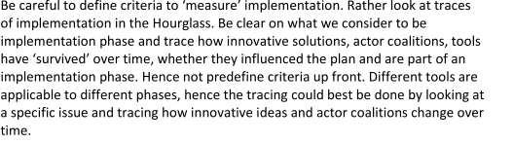
-The Hourglass framework, is it merely a heuristic framework (guiding research efforts) or also more normative. It seems to be more heuristic, so don’t put too much weight on it that it helps to integrate the research topics. In Ho Chi Minh it was also discussed as a framework to trace implementation:

